Data Handling And Visualization
Unit 2 Activity 2
24-07-2026

Amounts:
- Bar Graph:

Code:
library(ggplot2)
# Load data using your exact path
file_path <- "C://Users//yokes//Downloads//archive (3)//sales_data.csv"
df <- read.csv(file_path)
# Open interactive display window (Windows)
windows()
# Generate Bar Graph
p1 <- ggplot(df, aes(x = Product_Category, y = Sales_Amount)) +
geom_bar(stat = "summary", fun = "sum", fill = "skyblue", color = "black") +
labs(
title = "Bar Graph: Total Sales by Product Category",
x = "Product Category",
y = "Total Sales ($)"
) +
theme_minimal()
print(p1)
cat("Press [Enter] to close...")
readline()
Output:
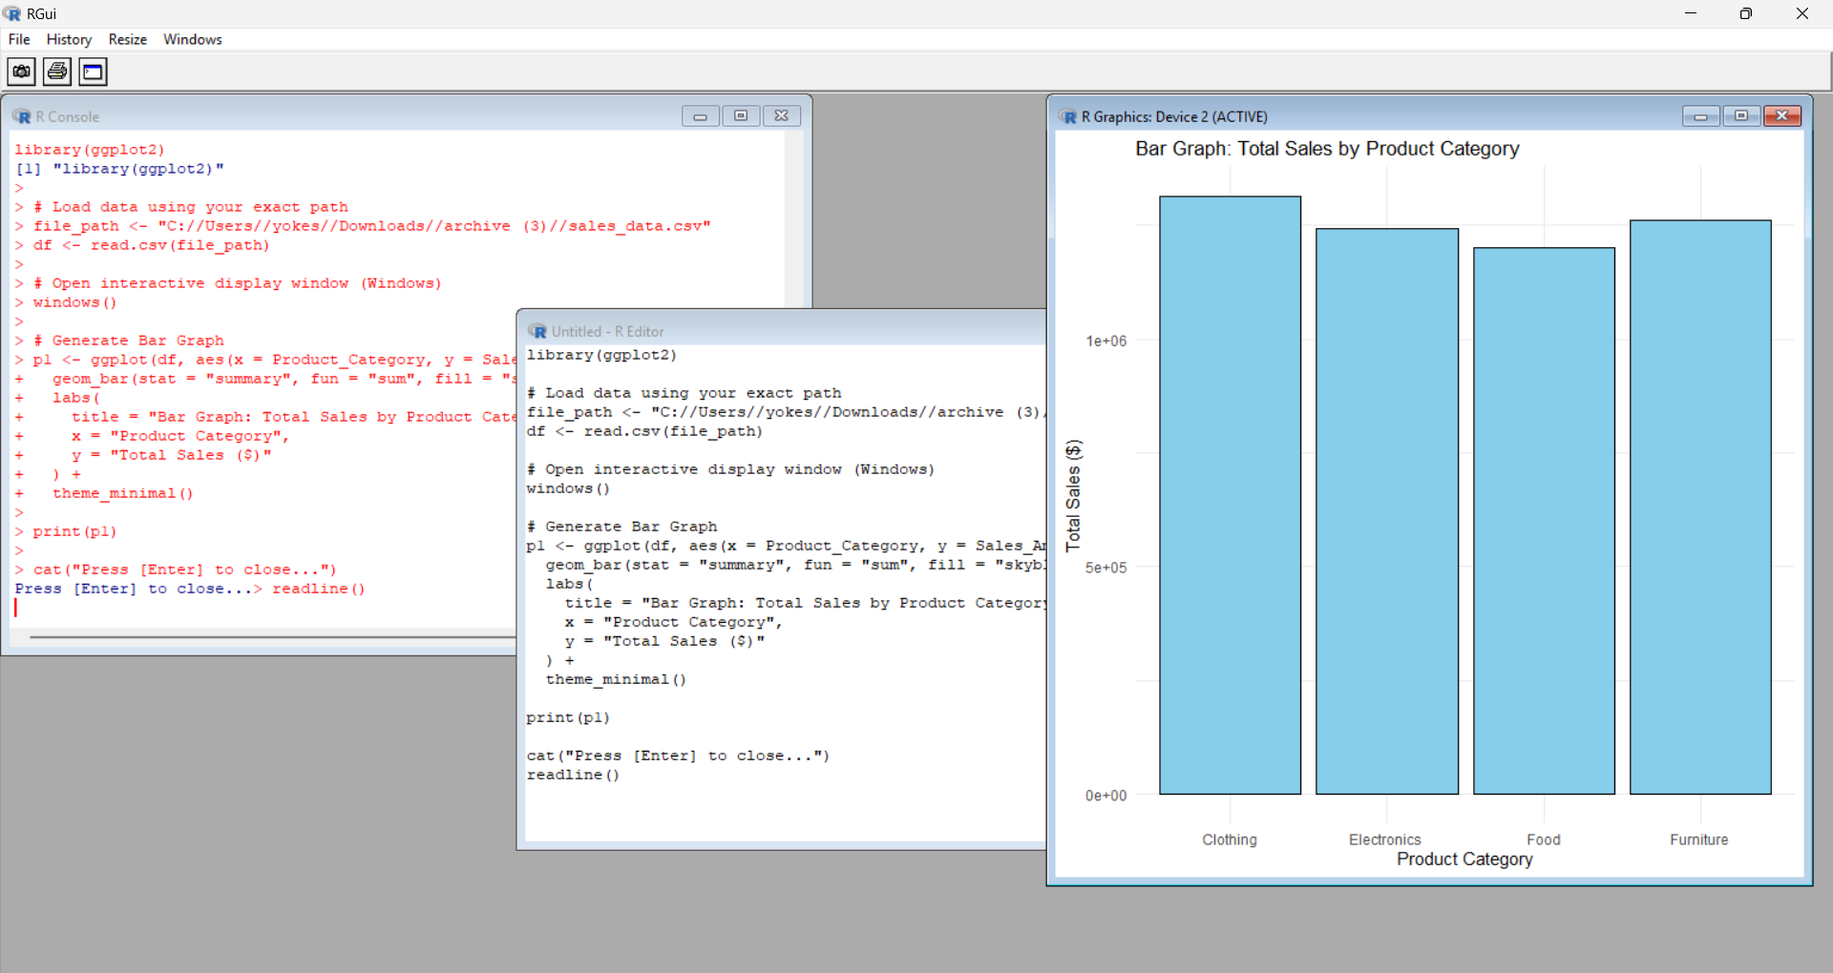

- Dot Plot

Code:
library(ggplot2)

# Load data using your exact path
file_path <- "C:/Users/yokes/Downloads/archive (3)/sales_data.csv"
df <- read.csv(file_path)
windows()
p2 <- ggplot(df, aes(x = Quantity_Sold, y = Sales_Amount, color = Product_Category)) +
geom_point(alpha = 0.7, size = 2.5) +
labs(
title = "Dot Plot: Sales Amount vs. Quantity Sold",
x = "Quantity Sold",
y = "Sales Amount ($)",
color = "Category"
) +
theme_minimal()
print(p2)
cat("Press [Enter] to close...")
readline()

Output:
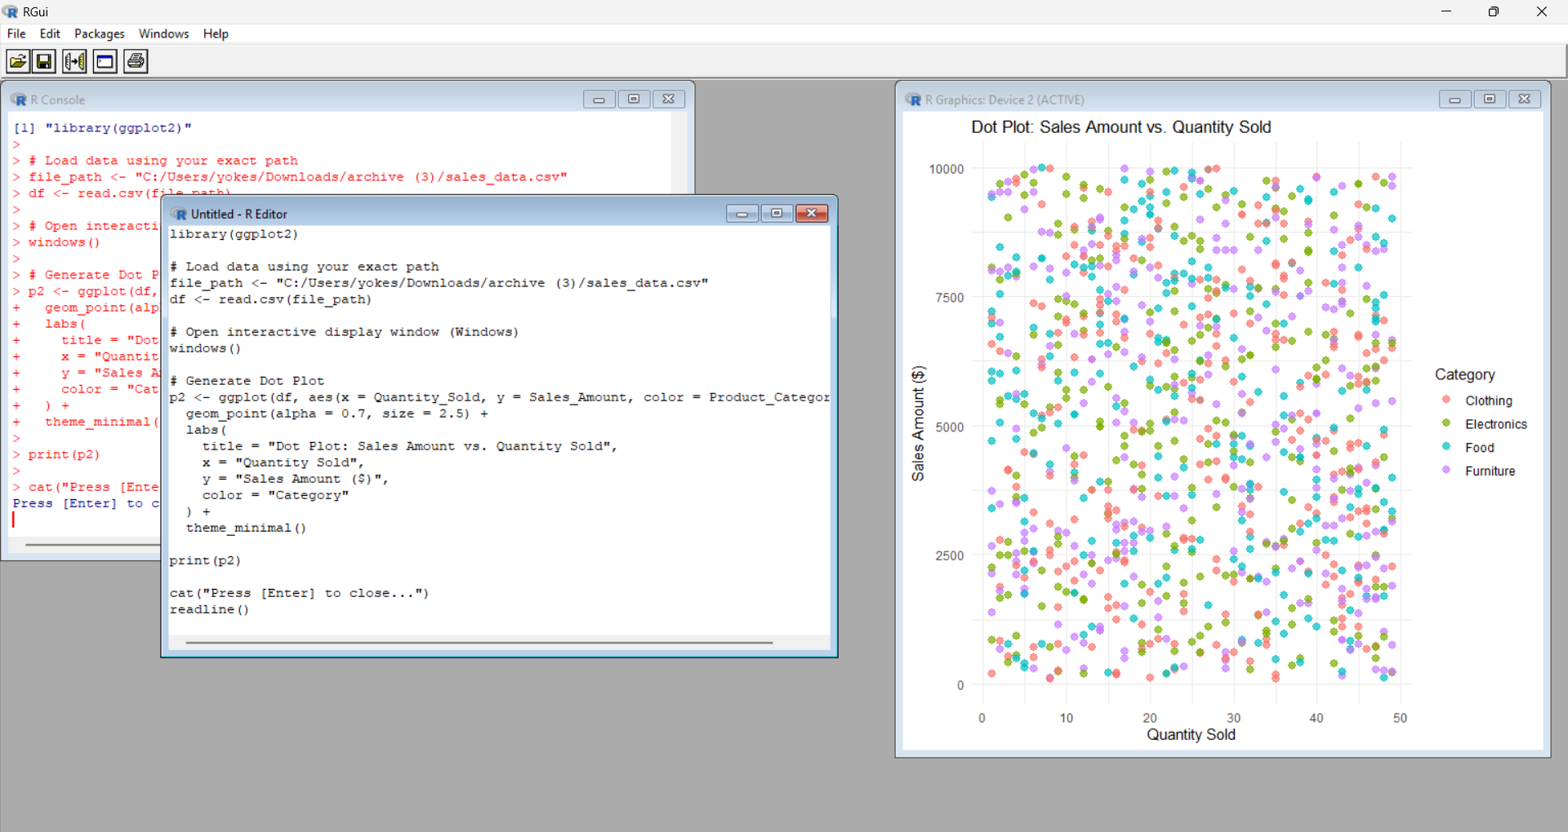

- Heat Map:

Code:
library(ggplot2)
file_path <- "C:/Users/yokes/Downloads/archive (3)/sales_data.csv"
df <- read.csv(file_path)
numeric_df <- df[, c("Sales_Amount", "Quantity_Sold", "Unit_Cost", "Unit_Price", "Discount")]
cor_matrix <- cor(numeric_df, use = "complete.obs")
cor_df <- as.data.frame(as.table(cor_matrix))
colnames(cor_df) <- c("Var1", "Var2", "value")
dev.new()
p3 <- ggplot(cor_df, aes(x = Var1, y = Var2, fill = value)) +
geom_tile() +
geom_text(aes(label = sprintf("%.2f", value)), color = "white", size = 4) +
scale_fill_gradient2(low = "blue", high = "red", mid = "white", midpoint = 0, limit = c(-1, 1)) +
labs(
title = "Heatmap: Correlation Matrix",
x = "",
y = ""
) +
theme_minimal() +
theme(axis.text.x = element_text(angle = 45, hjust = 1))
print(p3)
cat("Press [Enter] in terminal to close plot window...\n")
invisible(readline())

Output:
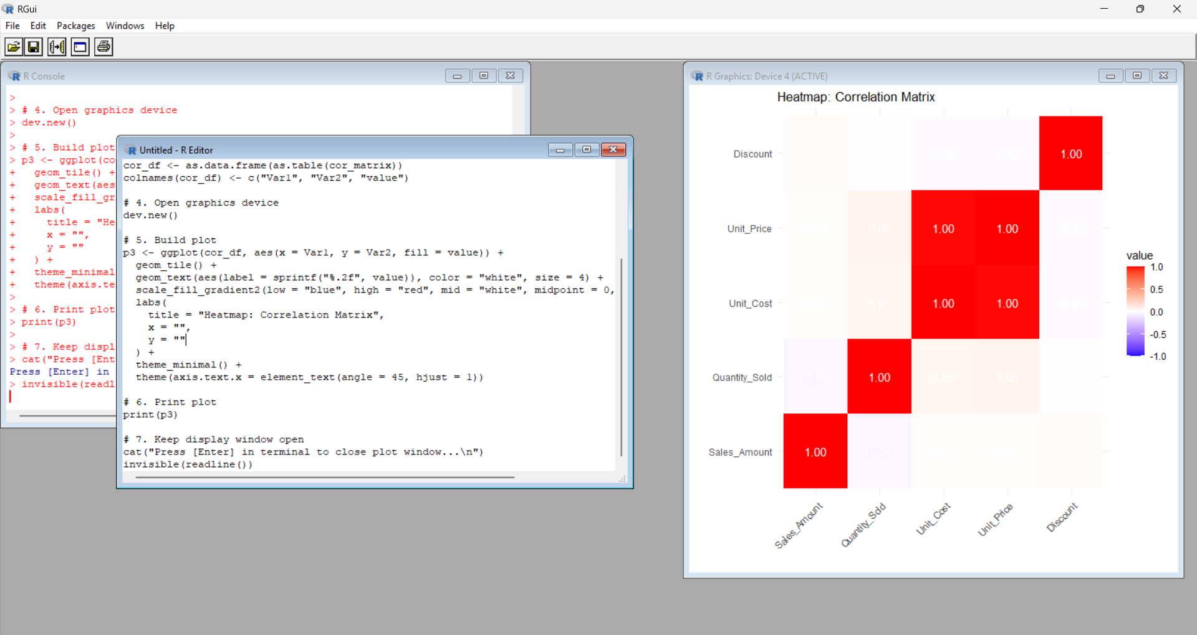

- Histogram
Code:
library(ggplot2)
file_path <- "C:/Users/yokes/Downloads/archive (3)/sales_data.csv"
df <- read.csv(file_path)
p4 <- ggplot(df, aes(x = Sales_Amount)) +
geom_histogram(bins = 20, fill = "turquoise", color = "black", alpha = 0.7) +
labs(
title = "Histogram: Sales Amount Distribution",
x = "Sales Amount ($)",
y = "Frequency"
) +
theme_minimal()
print(p4)

Output:
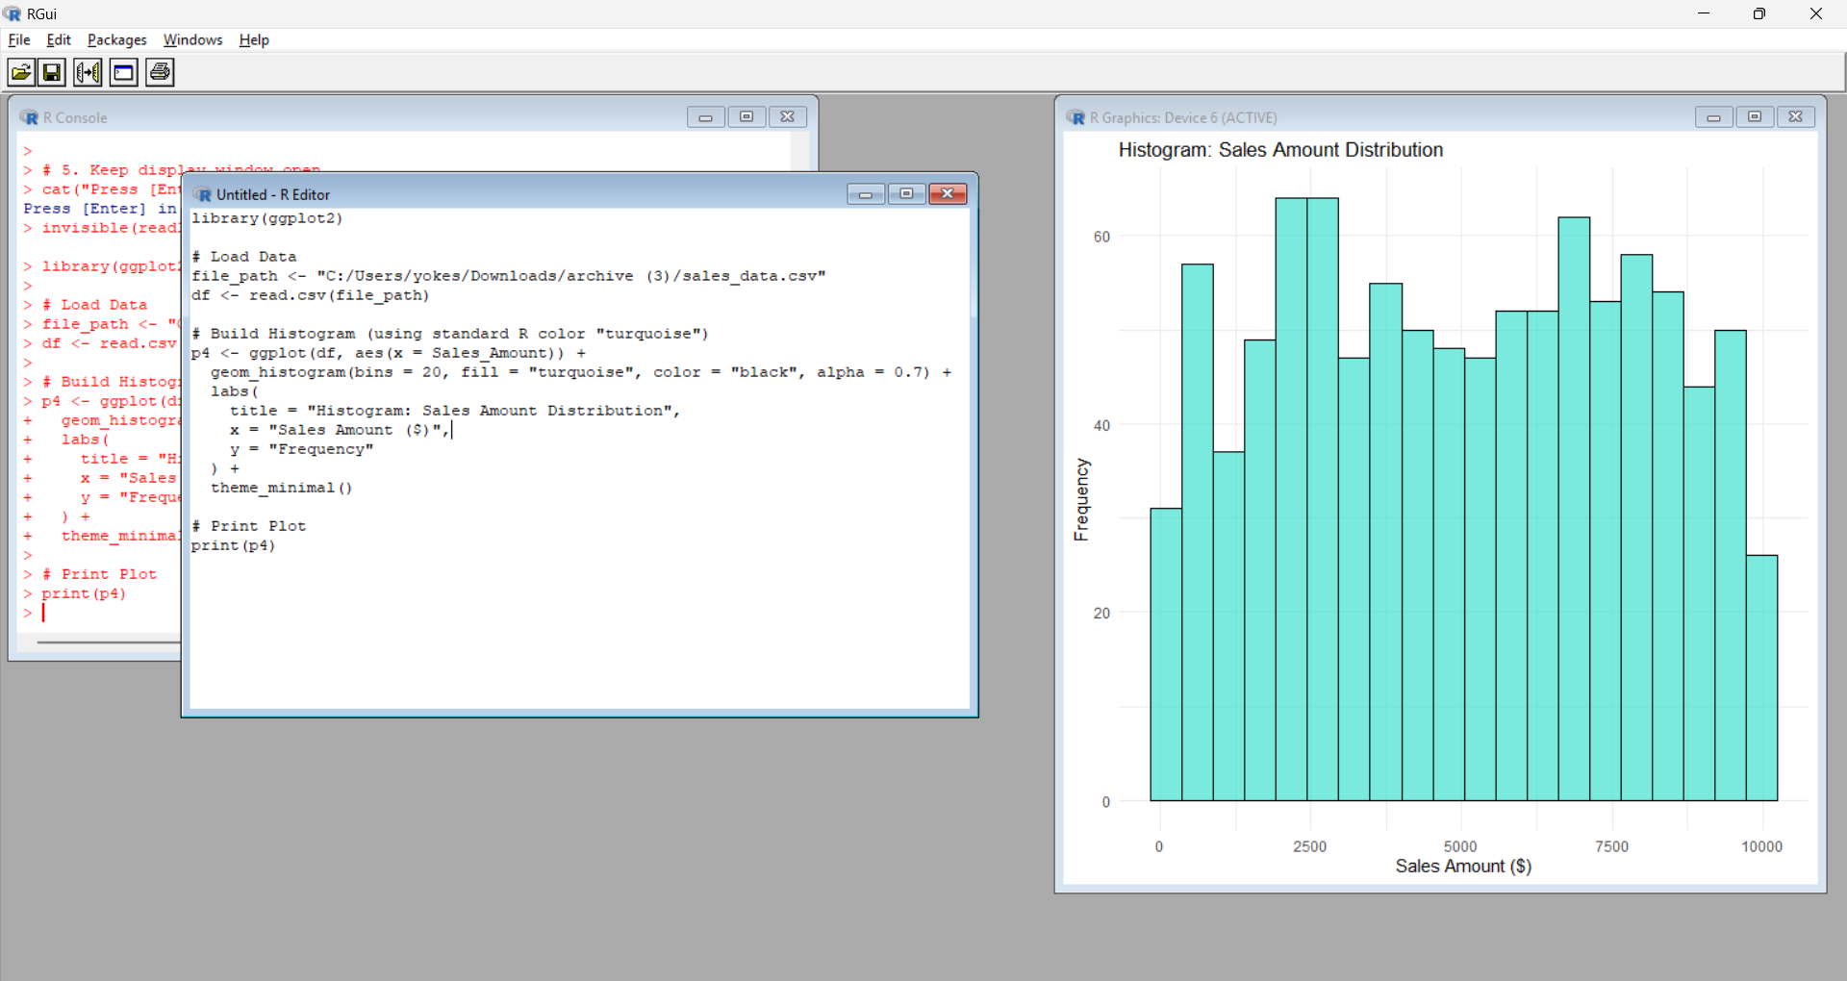

- Density Plot:
Code:
file_path <- "C:/Users/yokes/Downloads/archive (3)/sales_data.csv"
df <- read.csv(file_path)
windows()
d <- density(df$Sales_Amount)
plot(d,
main = "Density Plot: Sales Amount",
xlab = "Sales Amount ($)",
col = "purple",
lwd = 2)
polygon(d, col = rgb(0.5, 0, 0.5, 0.4), border = "purple")
Output:
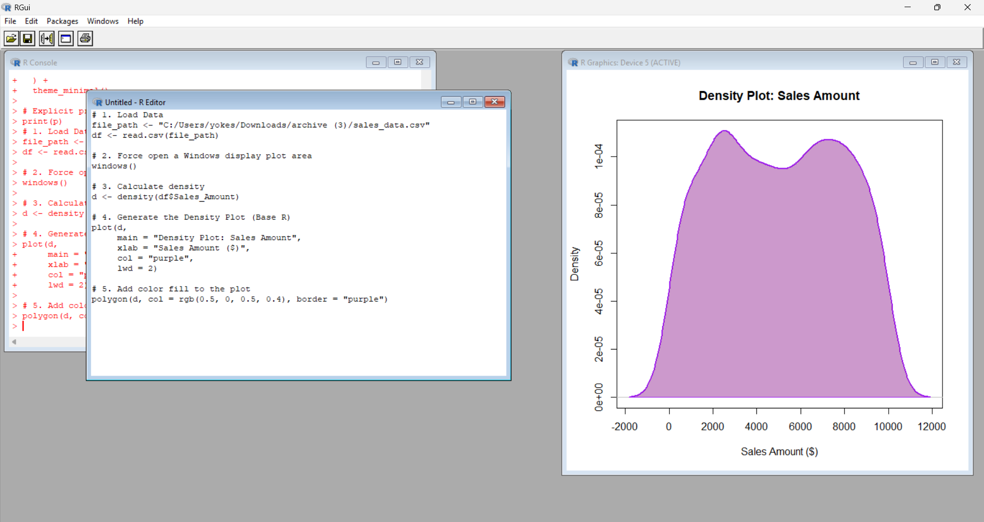

- Box Plot:
Code:
# Load Data
df <- read.csv("C:/Users/yokes/Downloads/archive (3)/sales_data.csv")
windows()
boxplot(Sales_Amount ~ Product_Category,
data = df,
col = c("lightblue", "lightgreen", "pink", "lightgoldenrod"),
main = "Box Plot: Sales Amount by Product Category",
xlab = "Product Category",
ylab = "Sales Amount ($)")

Output:
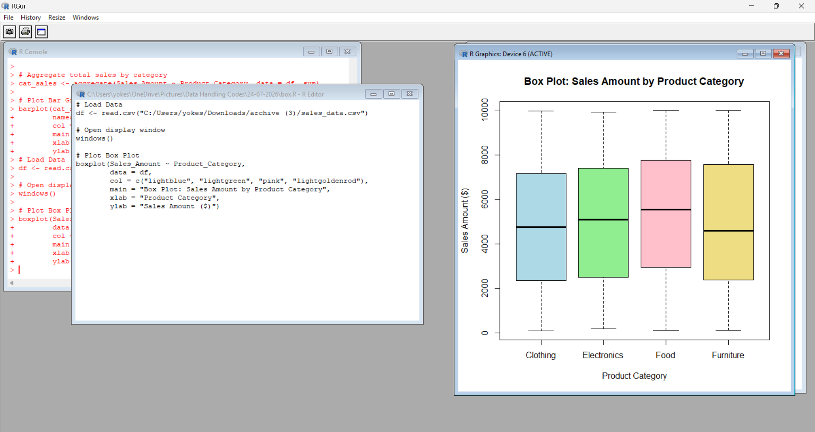

- Violin Plot:

Code:
library(ggplot2)
df <- read.csv("C:/Users/yokes/Downloads/archive (3)/sales_data.csv")
dev.new()
p_violin <- ggplot(df, aes(x = Product_Category, y = Sales_Amount, fill = Product_Category)) +
geom_violin(trim = FALSE, alpha = 0.6) +
geom_boxplot(width = 0.1, fill = "white", color = "black") +
labs(
title = "Violin Plot: Sales Amount Distribution by Category",
x = "Product Category",
y = "Sales Amount ($)"
) +
theme_minimal() +
theme(legend.position = "none")
print(p_violin)

Output:
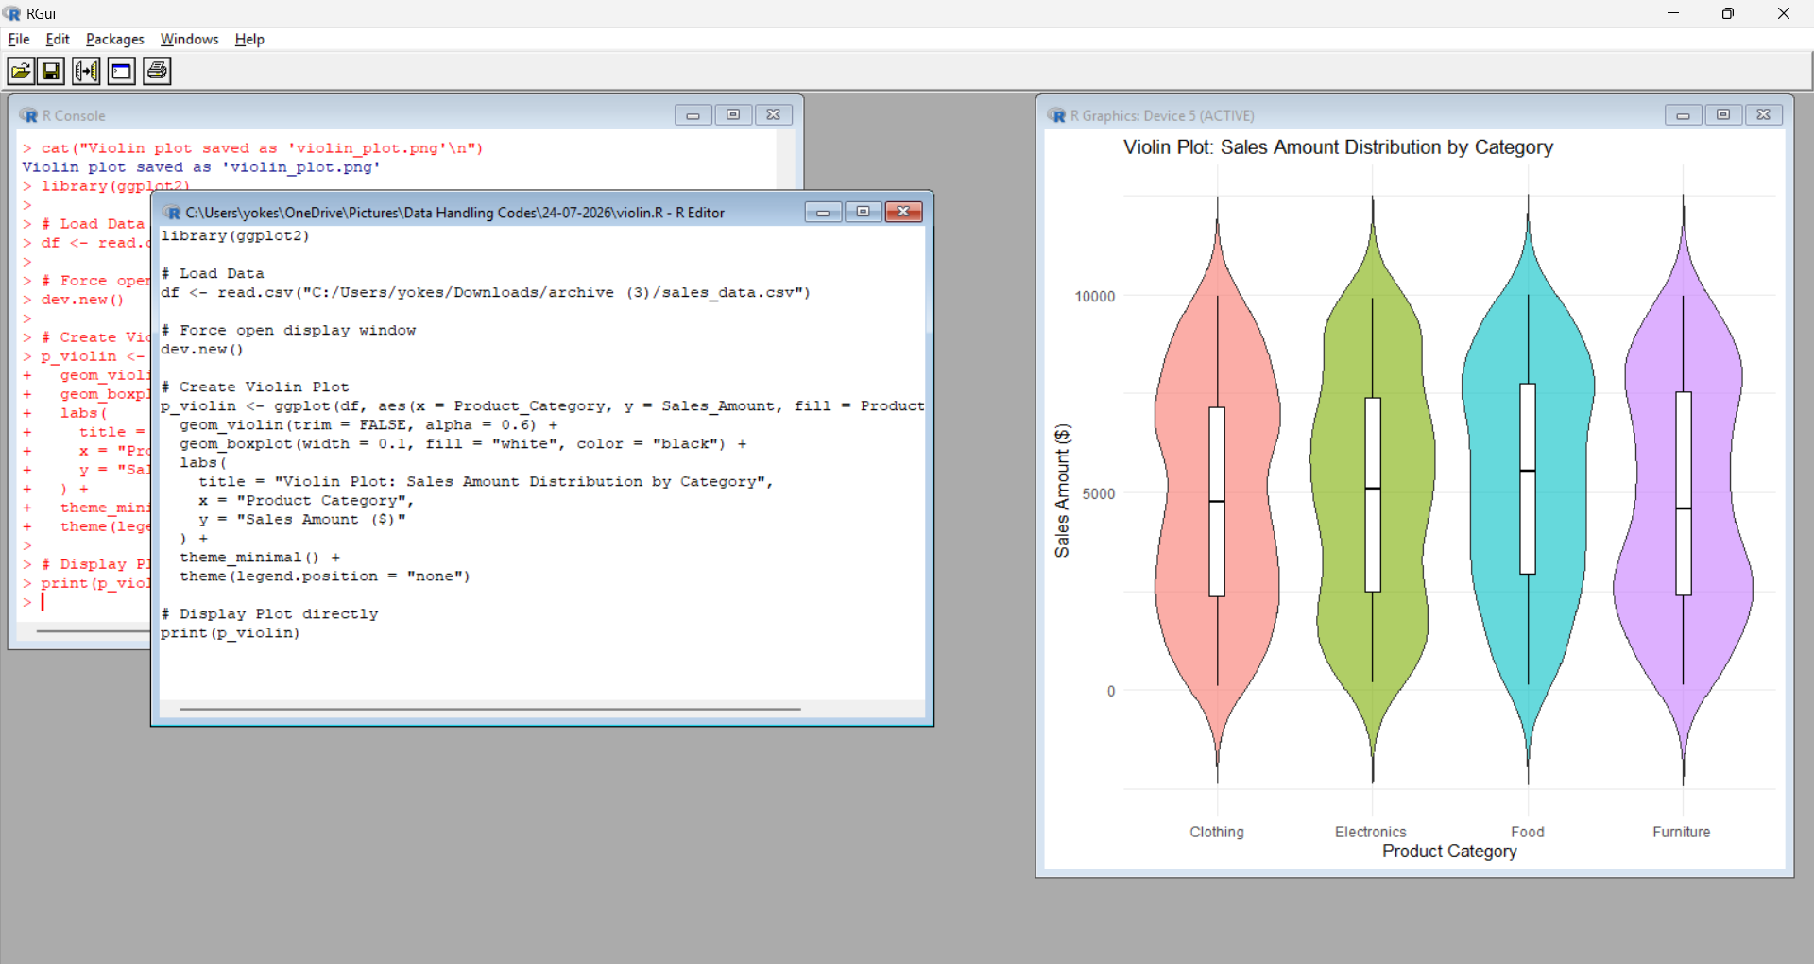

- Rigid Plot:

Code:
if (!require("ggridges")) install.packages("ggridges")
library(ggplot2)
library(ggridges)
df <- read.csv("C:/Users/yokes/Downloads/archive (3)/sales_data.csv")
ggplot(df, aes(x = Sales_Amount, y = Product_Category, fill = Product_Category)) +
geom_density_ridges(alpha = 0.7) +
theme_minimal() +
theme(legend.position = "none")

Output:
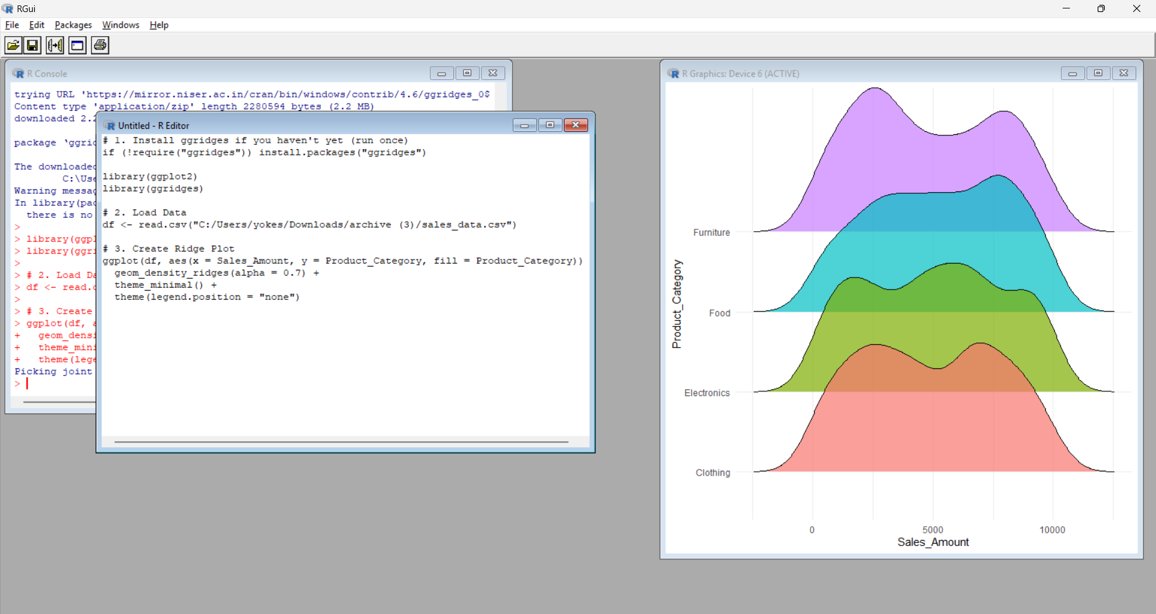

- Pie Chart:

Code:
df <- read.csv("C:/Users/yokes/Downloads/archive (3)/sales_data.csv")
cat_sales <- aggregate(Sales_Amount ~ Product_Category, data = df, sum)
pct <- round(100 * cat_sales$Sales_Amount / sum(cat_sales$Sales_Amount), 1)
labels <- paste(cat_sales$Product_Category, "-", pct, "%")
pie(cat_sales$Sales_Amount,
labels = labels,
col = rainbow(length(cat_sales$Product_Category)),
main = "Pie Chart: Total Sales Share by Category")

Output:
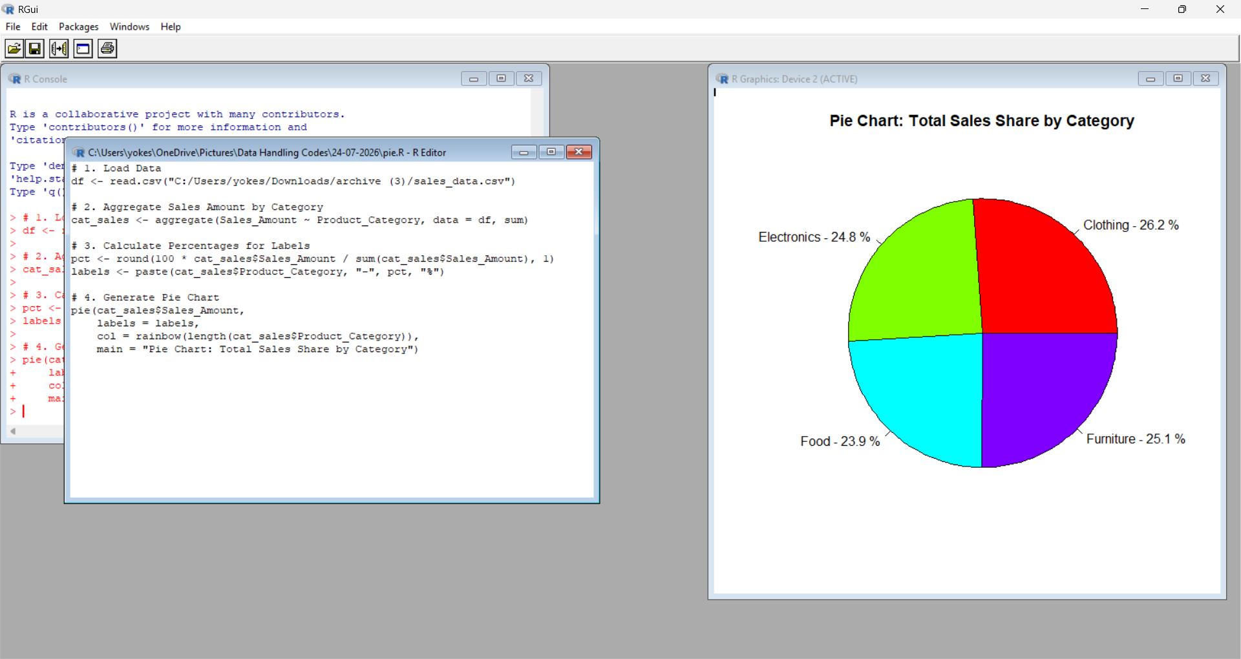

- Stacked Bar:

Code:
library(ggplot2)
df <- read.csv("C:/Users/yokes/Downloads/archive (3)/sales_data.csv")
ggplot(df, aes(x = Region, y = Sales_Amount, fill = Product_Category)) +
geom_bar(stat = "summary", fun = "sum") +
labs(
title = "Stacked Bar Chart: Sales Amount by Region & Category",
x = "Region",
y = "Total Sales ($)",
fill = "Product Category"
) +
theme_minimal()

Output:
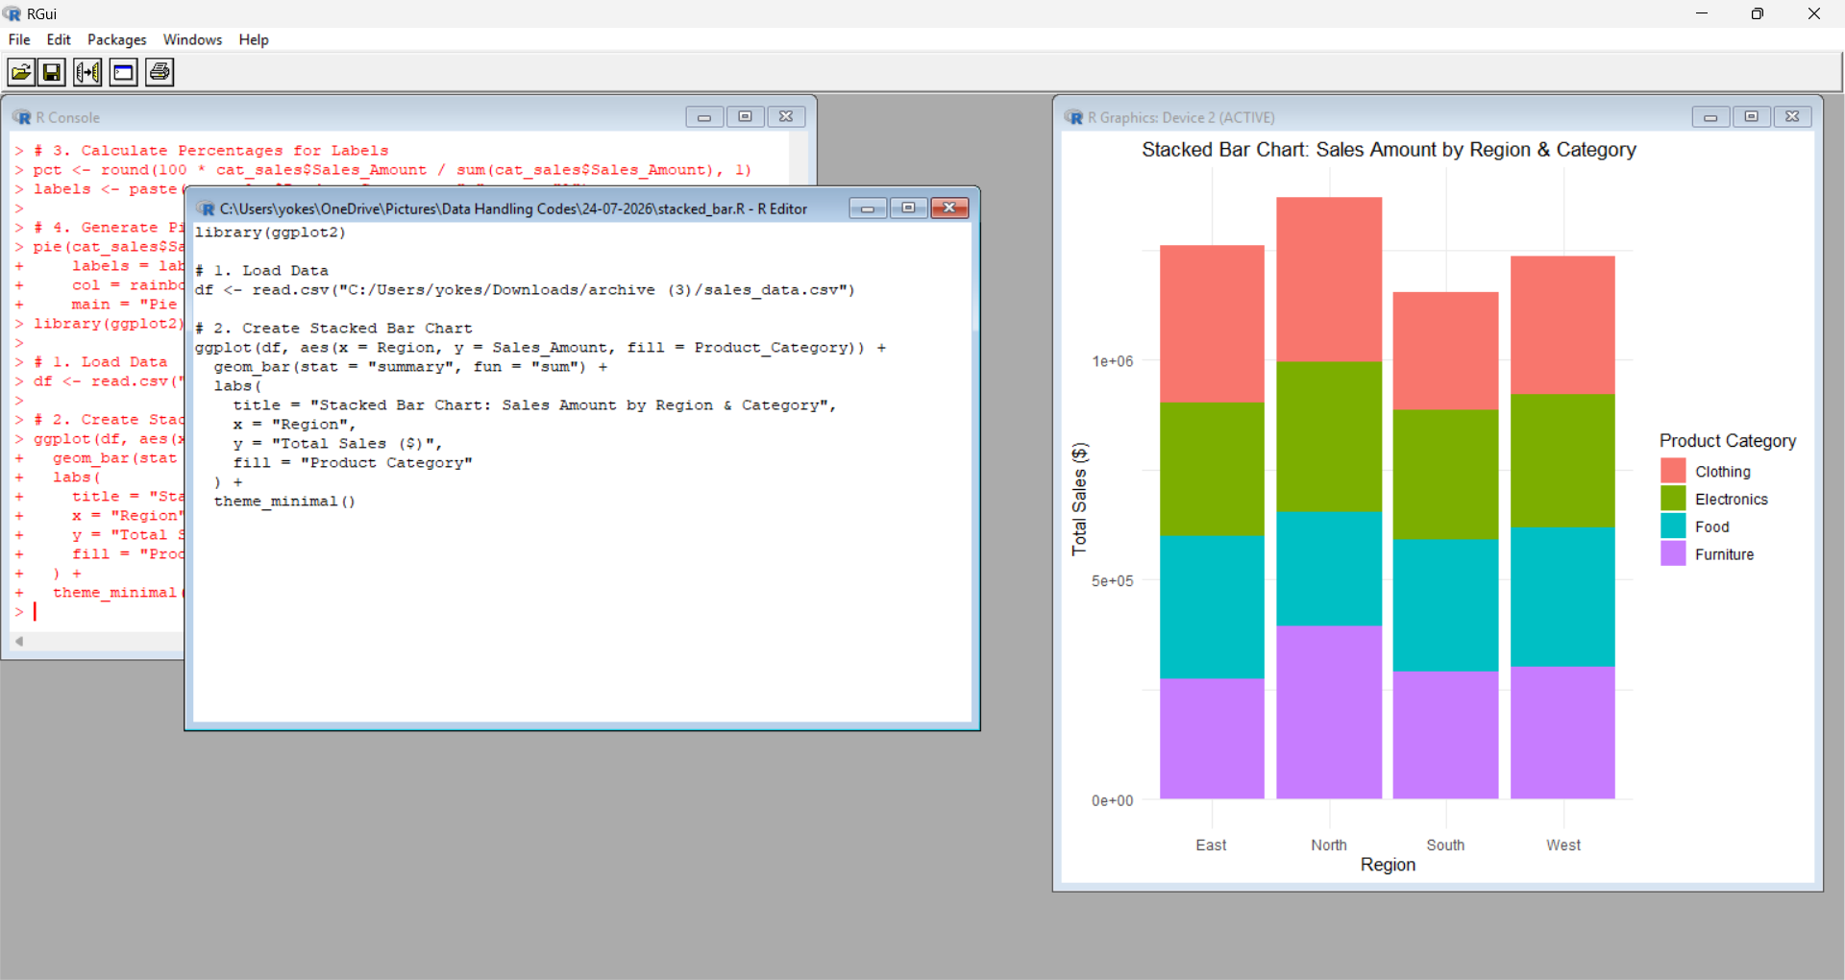
- Tree Graph;

Code:
install.packages("treemap")

library(treemap)
df <- read.csv("C:/Users/yokes/Downloads/archive (3)/sales_data.csv")
tree_data <- aggregate(Sales_Amount ~ Region + Product_Category, data = df, sum)
treemap(tree_data,
index = c("Region", "Product_Category"),
vSize = "Sales_Amount",
type = "index",
title = "TreeMap: Hierarchical Sales by Region and Category",
palette = "Set3")
Output:
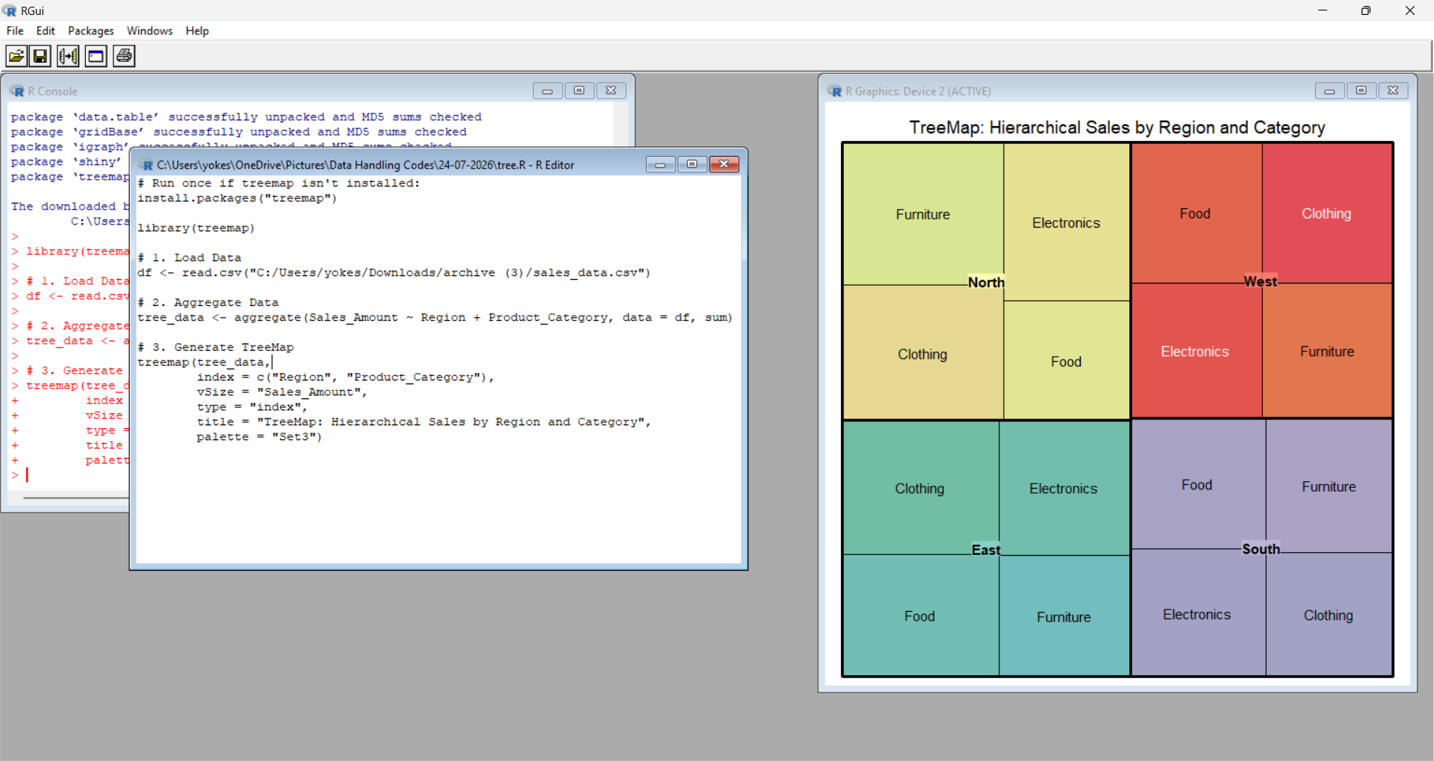

- SunBurst Plot:

Code:
install.packages(c("sunburstR", "dplyr"))
library(sunburstR)
library(dplyr)
df <- read.csv("C:/Users/yokes/Downloads/archive (3)/sales_data.csv")
sunburst_data <- df %>%
mutate(path = paste(Region, Product_Category, sep = "-")) %>%
group_by(path) %>%
summarise(value = sum(Sales_Amount))
sunburst(sunburst_data, legend = TRUE)
Output:
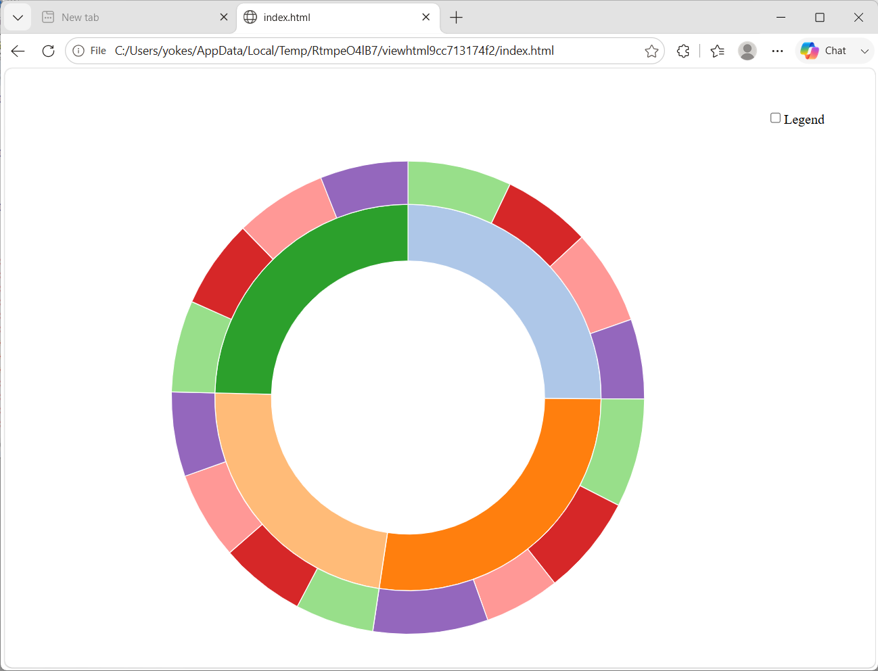

- Scatter Plot:

Code:
# 1. Load Data
df <- read.csv("C:/Users/yokes/Downloads/archive (3)/sales_data.csv")

# 2. Open graphics display window
windows()

# 3. Create Scatter Plot
plot(df$Quantity_Sold, df$Sales_Amount,
col = as.factor(df$Product_Category),
pch = 19,
main = "Scatter Plot: Sales Amount vs. Quantity Sold",
xlab = "Quantity Sold",
ylab = "Sales Amount ($)")

# 4. Add Legend
legend("topright",
legend = levels(as.factor(df$Product_Category)),
col = 1:4,
pch = 19)

Output:
